Inferential Statistics: Sampling & Confidence Intervals

🔍 1. What is Inferential Statistics?
Inferential statistics helps us make conclusions or predictions about a population using a sample of data.
- Population = everyone or everything we want to know about
- Sample = a smaller group taken from the population

🧪 2. Sampling

✅ Why Do We Sample?
Studying an entire population is often impossible (too large, expensive, time-consuming). A good sample can represent the whole population.

🎯 Types of Sampling
Type of Sampling | Description | Example
Random Sampling | Every member has equal chance | Pick 100 students randomly from a school
Stratified Sampling | Population divided into groups (age, gender), and sample is taken from each | 50 boys and 50 girls
Systematic Sampling | Select every k-th member | Choose every 10th customer
Convenience Sampling | Easy to reach people (risky, biased) | Survey your classmates only
⚠️ Important: A good sample must be random & unbiased to correctly represent the population.

📊 3. Sample Mean vs Population Mean
- Population Mean (μ) → True average of all data (unknown)
- Sample Mean (x̄) → Average from our sample (known)
We use x̄ to estimate μ.

🎯 4. Confidence Intervals (CI)
A Confidence Interval is a range of values that likely contains the true population mean.
Example: “We are 95% confident that the average height of students is between 160 cm and 170 cm.”

🧮 Basic Formula
Confidence Interval = x̄ ± Margin of Error
Margin of Error depends on:
- Sample size (n)
- Standard deviation (σ or s)
- Confidence level (90%, 95%, 99%)

🎚 Common Confidence Levels
Confidence Level | Meaning
90% | Moderate certainty
95% | Most common in science
99% | Very high certainty
Higher confidence → Wider interval
Lower confidence → Narrower interval

🧭 Example (Simple)
A teacher takes a sample of 50 students, average test score = 70, margin of error = ±5.
95% Confidence Interval = 70 ± 5 = [65, 75]
📌 Interpretation:
“We are 95% confident the true average score of ALL students is between 65 and 75.”

📢 Key Takeaways
Concept | Meaning
Sampling | Taking a small group to study a big population
Inferential Stats | Making predictions using sample data
Confidence Interval | Range that probably contains the true mean

🧪 Practical in Python — Sampling & Confidence Intervals

🔧 1. Setup Libraries
import numpy as np
import pandas as pd
from scipy import stats
import matplotlib.pyplot as plt
📖 Explanation
- numpy (np) → Used for generating numerical data (populations, samples, calculations).
- pandas (pd) → Usually used for data tables (not heavily used here, but often part of analysis).
- scipy.stats → Provides statistical functions like confidence intervals.
- matplotlib.pyplot → Used to visualize data and confidence intervals.
💡 Why Important?
These four libraries are the core tools for statistical analysis in Python.

🧠 2. Create a Population & Sample
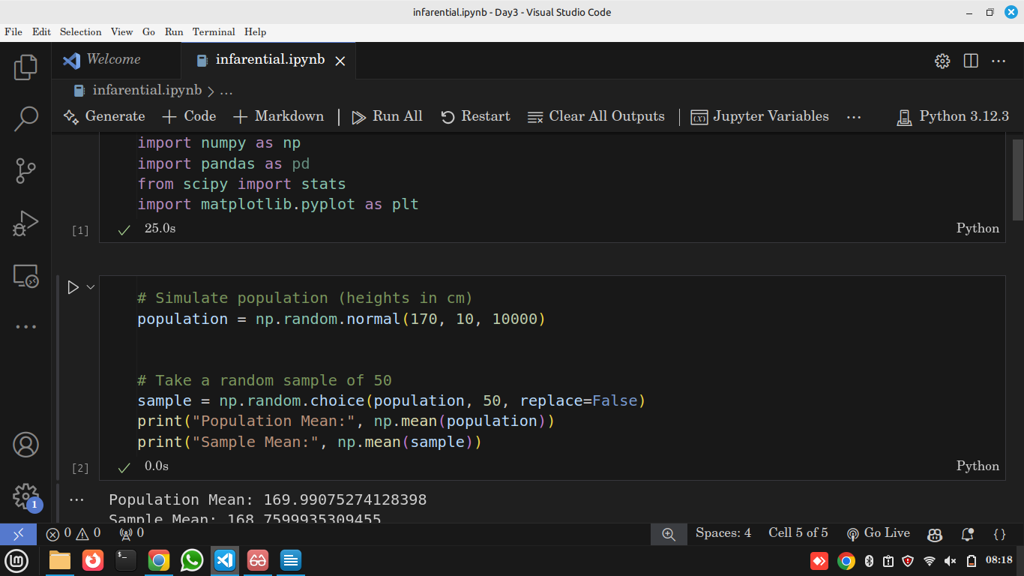
📖 Explanation
- np.random.normal(170, 10, 10000)
→ Creates 10,000 people’s heights, mean = 170 cm, std = 10 cm. (Population).
- np.random.choice(..., 50)
→ Randomly selects 50 people from the population (Sample).
- We print both Population Mean and Sample Mean to compare real vs estimated value.
💡 Insight (Real World)
Just like surveys or opinion polls — we don’t study everyone, we use a sample to estimate the population.

📏 3. Manual Confidence Interval (95%)
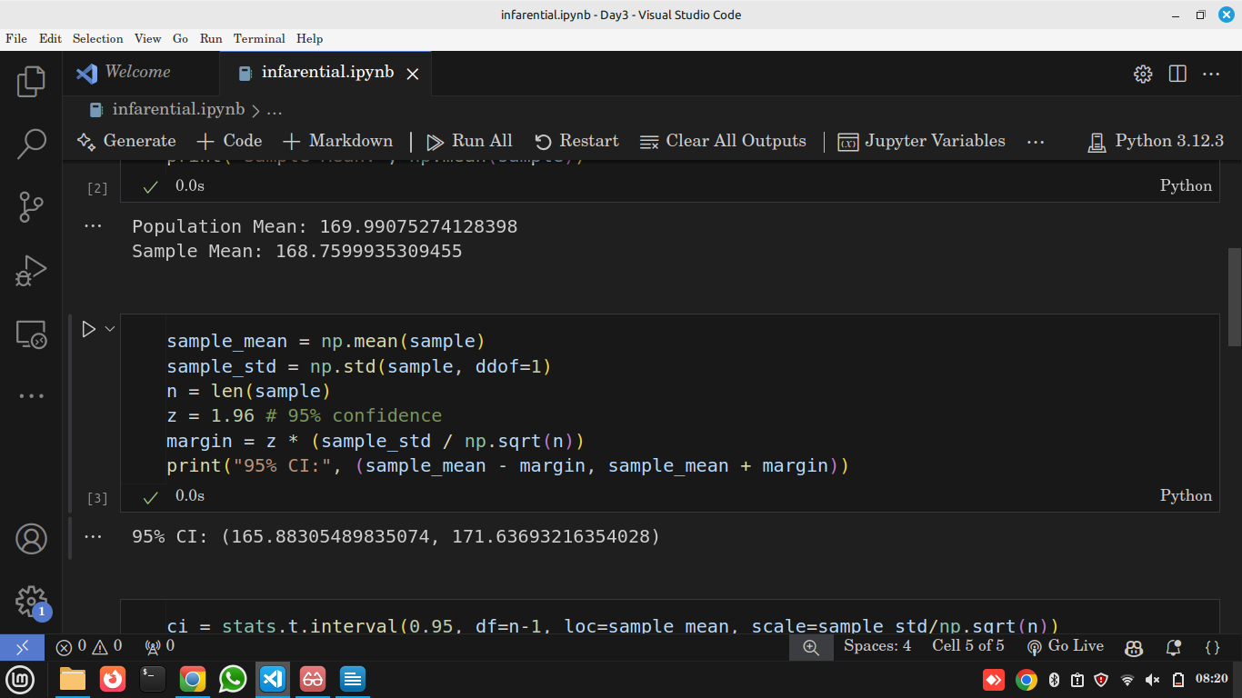
📖 Explanation
- sample_mean → Average height from our 50 people.
- sample_std → Variation within the sample (standard deviation).
- n → Sample size (50).
- z = 1.96 → Z-score for 95% confidence.
- margin = z * (sample_std / sqrt(n)) → Formula for margin of error.
- Final CI = sample_mean ± margin.
💡 Insight
We are saying:
👉 “We are 95% confident the true average height of the population lies within this range.”

🧪 4. SciPy Confidence Interval (Shortcut)
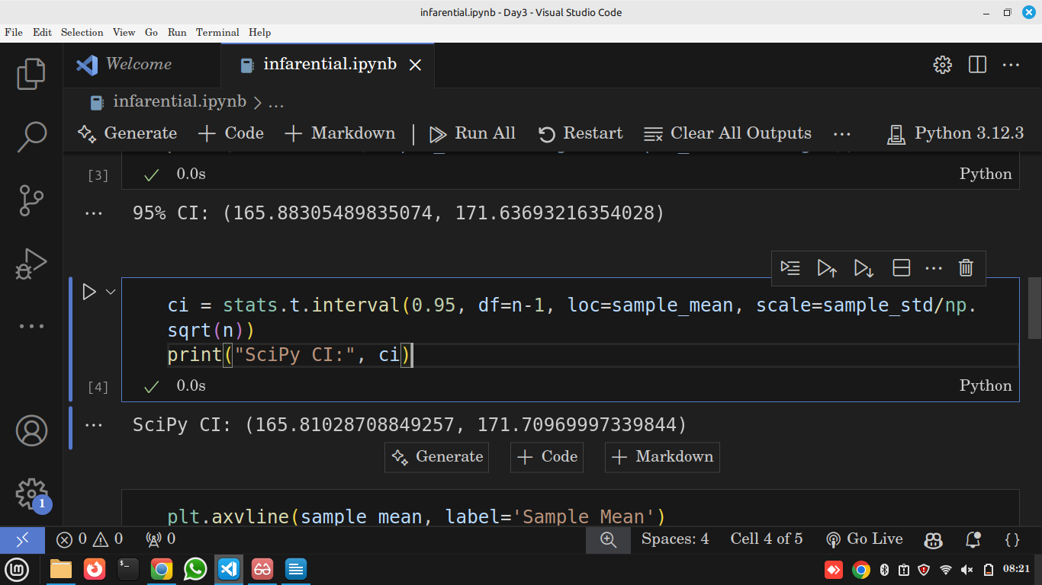
📖 Explanation
- stats.t.interval → Automatically calculates CI using the t-distribution.
- 0.95 → 95% confidence level.
- df=n-1 → Degrees of freedom (49).
- loc → Sample mean.
- scale → Standard error (std / √n).
💡 Why Use SciPy?
You don’t have to manually calculate — this is used in real data science projects for accuracy.

📊 5. Visualize Confidence Interval
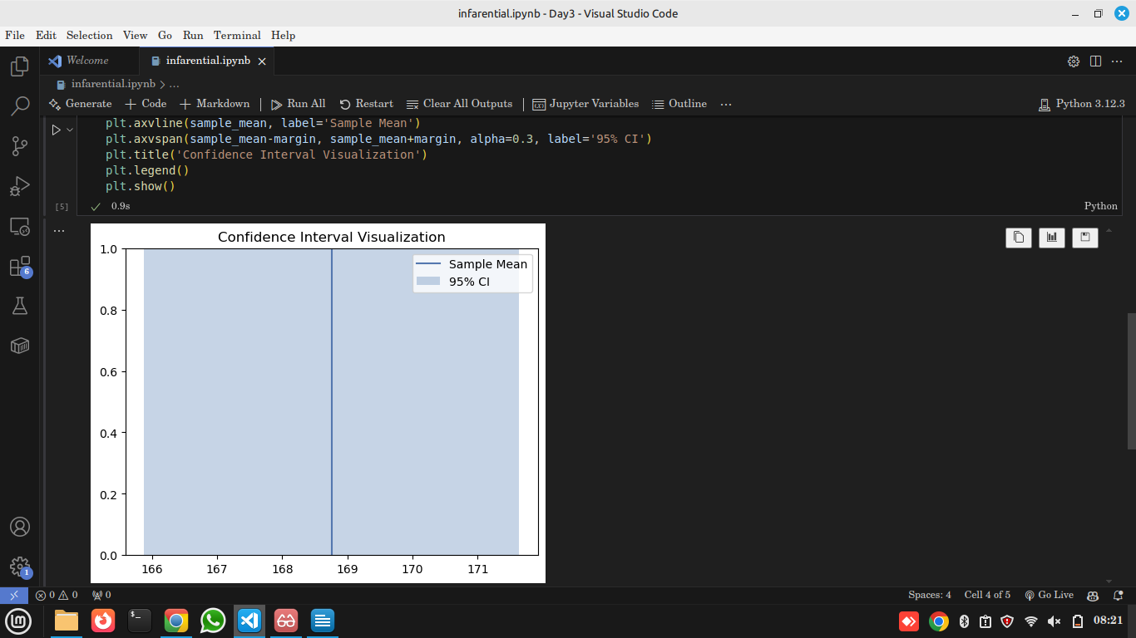
📖 Explanation
- axvline() → Draws a vertical line at the sample mean.
- axvspan() → Shades the confidence interval range.
- alpha=0.3 → Makes shading transparent.
- legend() → Shows labels.
- show() → Displays the plot.
💡 Insight
The shaded area shows all possible values where the true population mean could lie with 95% confidence.
If we repeat sampling 100 times → about 95 intervals will contain the true mean.

🌍 Real-World Applications of Sampling & Confidence Intervals

🏥 1. Medical Research & Drug Testing
When developing a new medicine, it’s impossible to test every single patient on Earth.
✅ Researchers test a sample of patients
✅ Calculate average recovery rate
✅ Use confidence intervals to estimate how effective the drug is in the entire population
🗣 Example:
"We are 95% confident that this drug improves recovery time by 4 to 6 days."

🗳️ 2. Opinion Polls & Elections
News agencies don’t interview every citizen before an election.
✅ They survey a sample of voters
✅ Calculate percentage support for a candidate
✅ Use confidence intervals to predict national results
🗣 Example:
"Candidate A is expected to get 52% ± 3% votes (95% CI → 49% to 55%)."

🏢 3. Customer Satisfaction & Market Research
Companies use surveys to test new products.
✅ They sample 1000 customers
✅ Estimate satisfaction level
✅ Use CI to infer how millions of customers might react
🗣 Example:
"We are 95% confident that overall satisfaction is between 80% and 85%."

🛠 4. Manufacturing & Quality Control
Factories cannot test every product due to cost/time.
✅ They measure a sample of products (e.g. bottle weights)
✅ Use confidence intervals to estimate if machine is working correctly
🗣 Example:
"Bottle weight is 500 ml ± 2 ml (95% CI)."

📈 5. Finance & Risk Estimation
Risk analysts compute average returns or losses using market samples.
✅ Use sample data (historical prices)
✅ Use CI to predict future earnings or risk range
🗣 Example:
"Expected portfolio return is 8% ± 1.5% (95% CI)."

🧠 Why Data Scientists Must Learn This
Concept | Real Use
Sampling | Saves time and cost, works with real-world limits
Confidence Interval | Measures uncertainty and reliability
Estimate Population Mean | Vital for prediction & decision making

Assignment

🕒 Time: 15 Minutes
- Short Answer & Practical Tasks

📝 Part A – Conceptual (5 min)
Answer in 2–3 sentences each:
- Sampling Error:
What is sampling error, and why does it occur in statistics?
- Confidence Interval (CI):
What does a 95% confidence interval really mean?
- Sample vs Population:
Why is it often impractical to collect data from the entire population?

🔍 Part B – Practical Application (7 min)
A company wants to know the average monthly spending of its customers. A sample of 100 customers shows an average spending of $250 with a standard deviation of $40.

1️⃣ Calculate the 95% Confidence Interval
Use formula:
CI = Mean ± 1.96 × (SD / √n)
Show your steps.
- Mean = 250
- SD = 40
- n = 100
Questions:
a) What is the margin of error?
b) What is the confidence interval range?

